Software Requirements Specification
For
“E-Visa System”

Prepared by <Code Crackers>
Group Members
- BSEF21M021(Laiba Shakoor)
- BSEF21M033(Imran Javed)
- BSEF21M034(Aalia Siddique)

Table of Contents

1. Introduction: 1
1.1 Project Details: 1
1.2 Purpose: 1
1.3 Intended Audience: 2
1.4 Revenue: 2
2. Problem Statement: 2
3. System Scope: 3
3.1 Actors Scope: 3
3.1.1 Applicant: 3
3.1.2 Embassy: 3
3.1.3 Bank: 3
4. Assumptions: 4
5. Functional Requirements: 4
6. Non-Functional requirements: 4
7. Business Rules: 5
8. Software Process Model: 5
9. Context Diagram: 6
10. Overview Diagram: 7
11. Use Case Diagram: 9
12. Sub-Use case Diagram: 10
13. Activity Diagram: 12.

Introduction:
When it comes to travelling overseas, the host country requires a visa specially if you are planning to stay there for an extended period of time.

“A visa is a conditional authorization granted by a territory to a foreigner, allowing them to enter, remain within, or to leave that territory. Visas typically may include limits on the duration of the foreigner's stay, areas within the country they may enter, the dates they may enter, the number of permitted visits or an individual's right to work in the country in question.”

E-Visa is simply a process of applying for visa through country’s visa website. They are just like other travel visas but the difference is that this process is completed online.

Project Details:
“E-Visa System” is an automated system. It is basically an application to apply for visa through an online system. It is actually a web-based application, the front end of the application will be your embassy website and the back end will be the visa processing system. The best part of this application is that it can be accessed from anywhere i.e. home and office etc. Every visa official has a list of requirements. Applicant looks for them after logging into the system and then apply in his desired category. All the major categories of the visa are discussed here. And interestingly, all the categories have their own requirements so the applicant has to fulfill them in order to apply for the visa. The applicant can check his approval or rejection of visa after submitting the form and paying fee.

Purpose:
Manually, the user has to go to the embassy or consulate personally with mounds of paper work in tow and apply for the visa. It is very difficult because of travelling and other inconveniences. And they have to anxiously wait for months for the documents to be approved. But E-visa is more preferable because it facilitates the applicants by saving their time and cost. They can view and apply for visa from anywhere anytime and view their approval through e-mail.
Standard paper application is a pain to fill out and the manual documentation is even a challenging task that’s why both the embassy and applicants are comfortable with the online process. Moreover, in this modern era of technology, more people have access to the online applications and the online applications are coded in such a way that they cannot be submitted until their completion, so it is a better way to apply for visa as compare to the manual process.

Intended Audience:
The intended audience in this project will be applicant and embassy administrator. Primary actor will be the user of this application i.e. applicant who is going to apply for the visa and the secondary actor will be the embassy administrator and bank. Embassy who would verify and check the application form and documentation and then approves or rejects the visa. While the application fee will be paid through bank.

Revenue:
E-Visa system gives us a good revenue as compare to formal visa applying process. Out of 100% revenue, 40% would be utilized in the data processing, 19% is given during the international transaction, 35% is given to other services in which the embassy and government of that state is included and 5% is used and given to the other agencies and systems.

Problem Statement:
Manually, the user has to go to the embassy or consulate personally with mounds of paper work in tow and apply for the visa. It is very difficult because of travelling and other inconveniences. And they have to anxiously wait for months for the documents to be approved. But E-visa is more preferable because it facilitates the applicants by saving their time and cost. They can view and apply for visa from anywhere anytime and view their approval through e-mail.
Standard paper application is a pain to fill out and the manual documentation is even a challenging task that’s why both the embassy and applicants are comfortable with the online process. Moreover, in this modern era of technology, more people have access to the online applications and the online applications are coded in such a way that they cannot be submitted until their completion, so it is a better way to apply for visa as compare to the manual process.

System Scope:
E-Visa saves applicant from tough bureaucratic procedures and tiring
Journey. It allows the embassy and applicant to complete the process in a virtual environment. Application, documentation, submission and fee payment is done online and hence everything is done via internet which is, nowadays, a much more convenient way than other sources. Labels and stamps are not required because everything is done in an online environment. E-Visa system of any state always deals its applicants in international currency .i.e. USD $ and endorsement of foreign currency equivalent to USD 150$ per applicant.

Actors Scope:
There are three actors in this system. The scope of each actor is given below:

Applicant:
The applicant’s responsibility is to submit all the documents required to complete the application. He has access to the visa status.

Embassy:
The embassy’s responsibility is to collect all the documents and information provided by the applicant and verify them. Then it has the right to approve or reject the application.

Bank:
The bank’s responsibility is to collect the application fee provided by the user and then submit the verification slip to the embassy.

Assumptions:
- The applicant has to submit a copy of CNIC (Identity Card) if the applicant’s age is more than 18 years.
- The user may have the knowledge to understand system’s interface and use the system
- The applicant has to submit a copy of Child Registration Certificate (B-Form) if the applicant’s age is less than 18 years.
- A copy of passport is also mandatory to submit.
- A copy of CNIC of the applicant’s Father/Guardian is also mandatory to submit.

Functional Requirements:
The functional requirements of the system are given below:
- The applicant would open the application form to apply for visa.
- The applicant should add personal details.
- The applicant should add passport details.
- The applicant would pay the application fee.
- The applicant can track his visa status.

Non-Functional requirements:
The non-functional requirements of the system are given below:

- The applicant would login to the system.
- Maintainability
- Reliability
- Recoverability
- Usability
- Security
- Privacy concerns are considered.
- 24 hours service availability.
- Manageability

Business Rules:
The business rules of the system are given below:
- This system will not give visa of Israel due to the foreign policy issues of Pakistan.
- This system will give visa of India depending upon the relations between both countries at that time.
- There is no refund policy of the payment in this system.

Software Process Model:
The Software Process Model of this system is “Waterfall Model”. Here are the reasons:

- Requirements are understandable and well-defined.
- The requirements do not changes throughout the whole system.
- We define the requirements early in the system.
- As we are making this system for the first time, so we do not require any experience of the existing system.
- Less domain knowledge is required.
- Less experience on tools to be used.
- There is no need to involve the user in making process.
- Less cost required in making the system.
- No time limit.

Context Diagram:

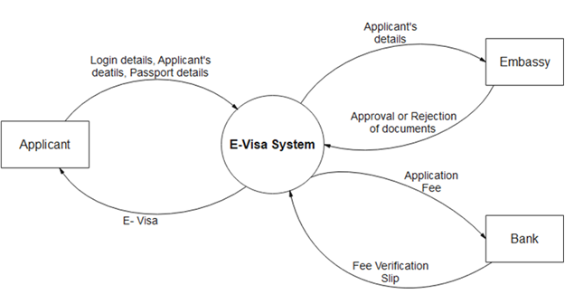

- Firstly, the user enters his login details.
- When the applicant is logged in, he enters all his personal, passport and professional details to apply for the visa.
- Then the applicant pays the application fee and gets the fee verification slip.
- The system then transfers all the details of the applicant to the embassy.
- The embassy verifies the documents and all the details and approves or rejects the application according to the criteria of the verification.
- The applicant can view his application status also. If the E-visa is issued by the embassy, then the applicant can view / print the E-Visa.

Overview Diagram:

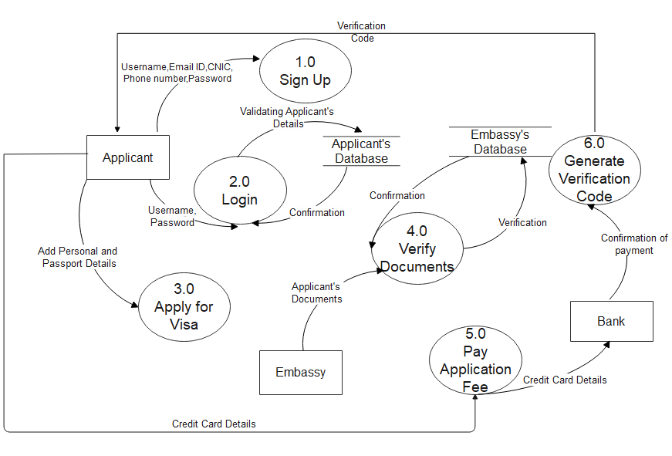

- The applicant will first sign up to the system and provide personal details like username, password, email address and CNIC. All of these details would be stored in applicant’s database.
- Applicant will enter username and password for login, then these details will be verified from applicant’s database and a confirmation message will be send back to the process.
- The next process is about applying for the visa .Applicant will open the application form and then add personal and passport details and apply for the visa. These details would be stored in the embassy’s database.
- Applicant’s documents will be verified in the next process from the embassy’s database and a confirmation message will be send back to the process.
- Applicant will pay the application fee in the bank by using his credit card. In the next process, the bank will generate fee verification code for the confirmation of payment and a verification ID would be sent back to the applicant so he could know about his approval or rejection.

Use Case Diagram:

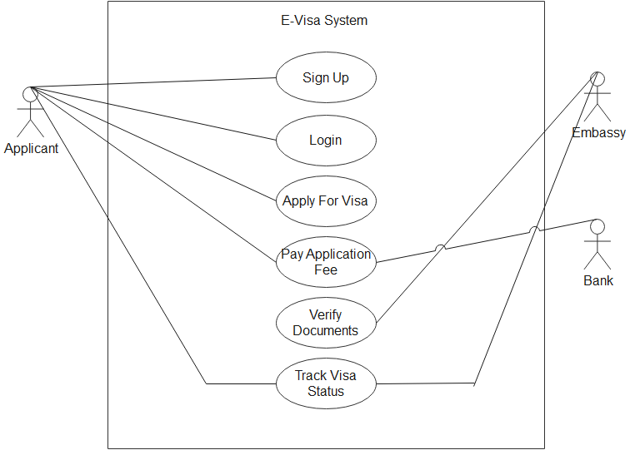

Sub Usecases:
- LOGIN
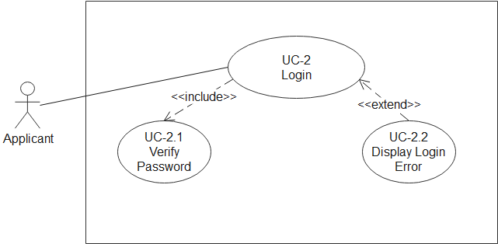

- APPLY FOR VISA
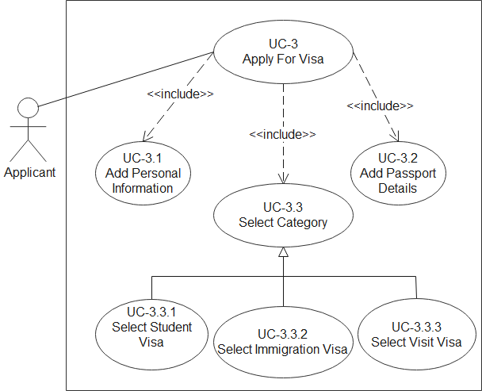

- PAY APPLICATION FEE
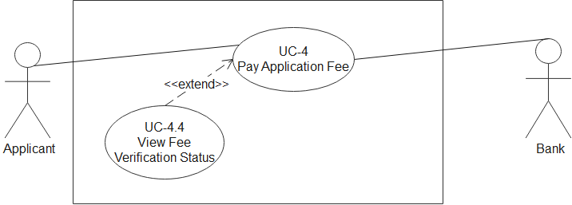

- VERIFY DOCUMENTS

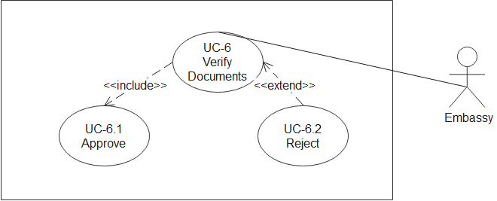

13. ACTIVITY DIAGRAM:

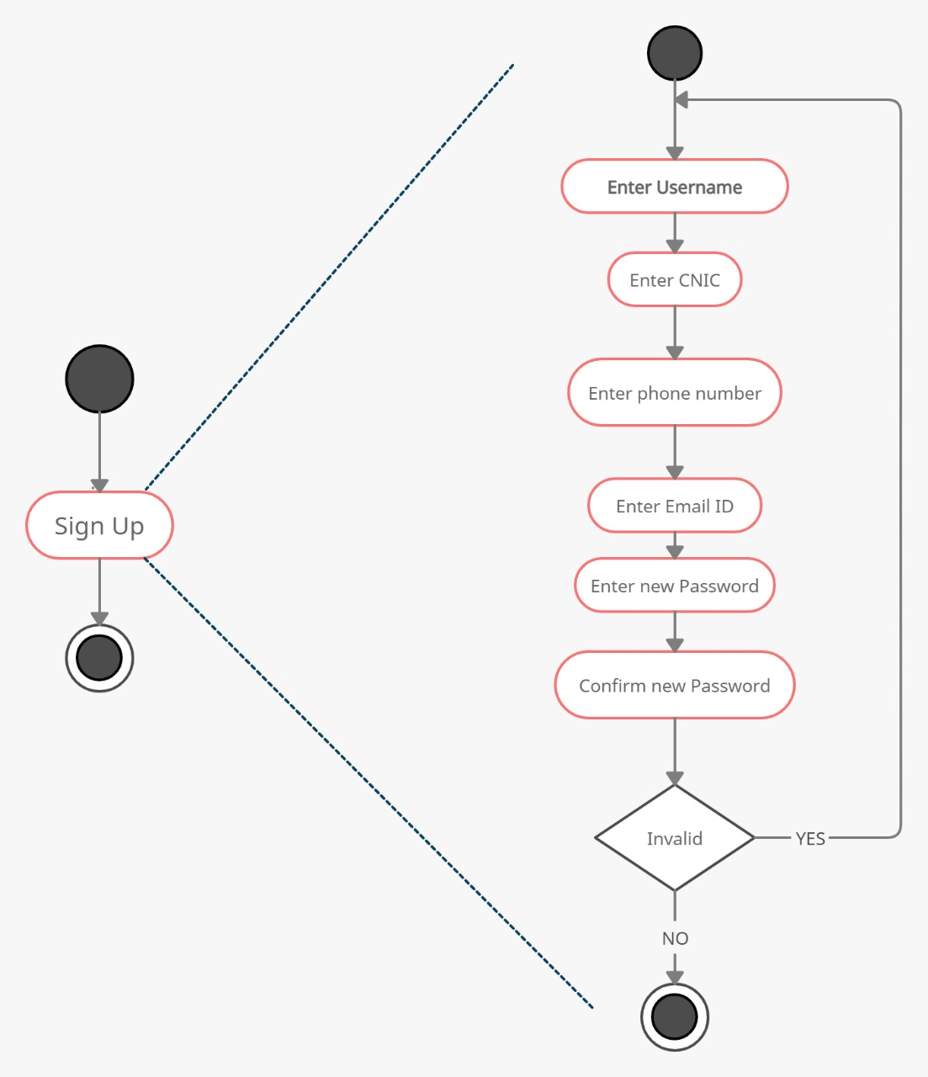
SIGN UP:
- The new applicant is required to sign up in order to apply for the visa
- The applicant will enter his details like username, CNIC number, phone number, e-mail address.
- If all the details are accepted by the system, the user would be asked to create a strong password and apply for the visa.
- If all the details are valid, the user would sign up to the system, otherwise, the system will ask user to sign up again by adding valid details.

Invalid

Valid

L
o
gin

Username

Password

Forget
Password

Visa
Rules
&
Regulations

E
nter
existing
U
ser
name

E
nter
ph
one
number

E
nter
verification
code

R
eset
password

V
erify
password

Login:
- The user is asked to enter the username and then the password.
- If the password is Valid, the system will display visa rules and regulations.
- If the password is Invalid, the system will show forget password tab. By clicking on it, the user will enter existing username, phone number, and verification code and reset password sequentially.
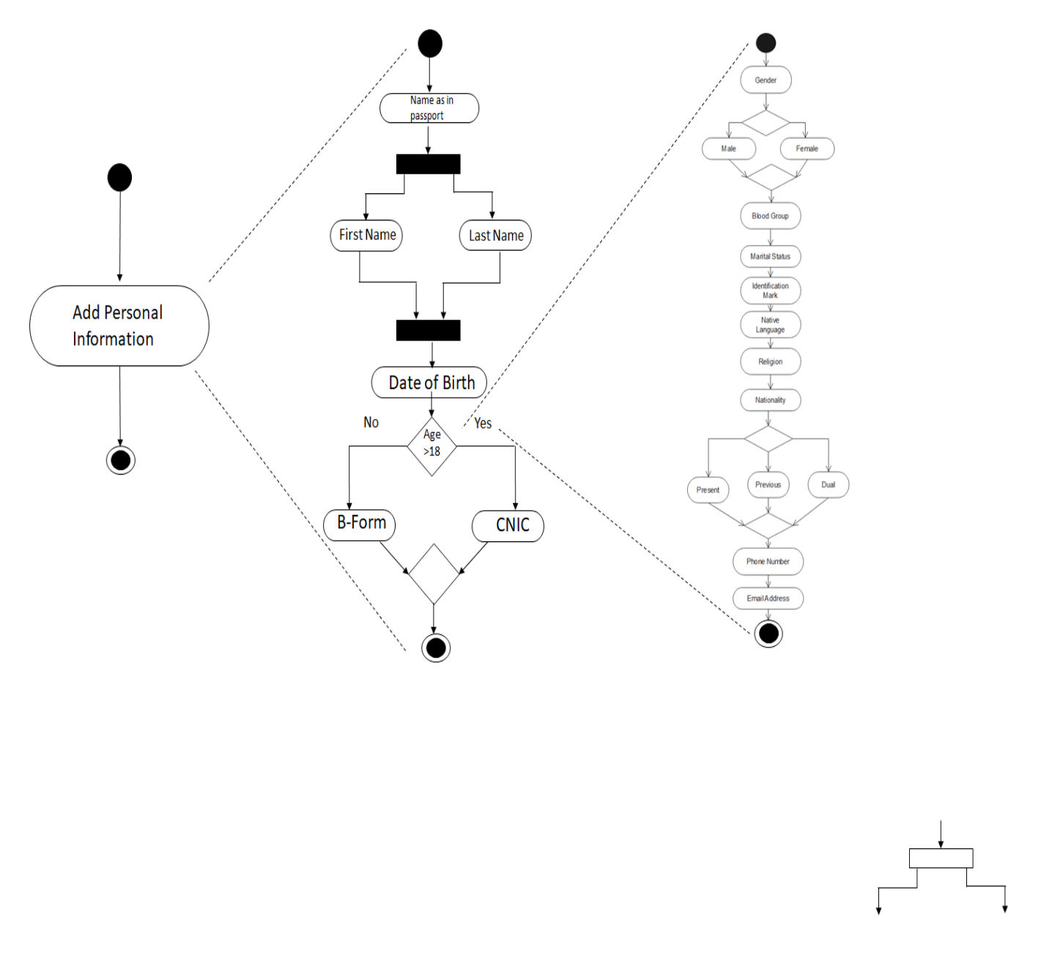
Add Personal info:
- In this step, the user is required to enter the name of him as mentioned in passport.
- Then the user is required to enter his Date of birth.
- If his age is more than 18, then he has to submit CNIC.
- If the age is less than 18, then he has to submit B-Form.
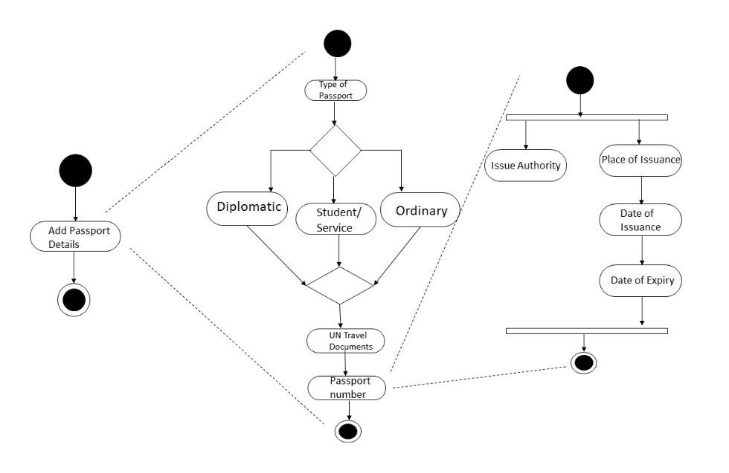
Add Passport details:
- In this step, the user is required to enter the type of passport.
- There are three categories of passport i.e. Diplomatic, Student/Service and Ordinary passport.
- Then the user is required to enter UN Travel documents.
- After entering this, the user is required to enter passport number.
- The applicant will also enter the date of issuance and date of expiry of the passport.

